GRANARD MUNICIPAL DISTRICT

Minutes of Meeting of Granard Municipal District held in the Council Chamber, Aras an Chontae, Longford on Tuesday, 24th October 2017 at 3.30 p.m.

CATHAOIRLEACH: Councillor P.J. Reilly.

MEMBERS PRESENT: Councillors – Paraic Brady, Michael Carrigy, Martin Mulleady and Luie McEntire.

IN ATTENDANCE: Mr. John Brannigan, Director of Services.
Mr. John McKeon, Head of Finance.
Mr. David Coppinger, Senior Executive Engineer.
Ms. Ann Marie McKeon, Administrative Officer.

APOLOGY: Councillor John Duffy.

MEETINGS
ADMINISTRATOR: Ms. Anne Lee.

2018 GENERAL MUNICIPAL ALLOCATION.

J. McKeon gave a comprehensive presentation regarding the General Municipal Allocation
2018 under the following headings and replied to queries raised -
- Budgetary Process – under Local Government Reform Act 2014.
- Sources of Funding for Municipal Districts.
- Local Government (Financial & Audit Procedures) Regulations 2014.
- Budgetary Bases of Allocation.
- Increased Allocation 2018.
- Any Increase over Base Rate for 2018 – “Contract with our Communities”
- Overall GMA 2017 v 2018
- Granard MD 2017 GMA – Committed to Date.
- Proposed Granard GMA Sub-Service Allocation for 2018.
- Members Countywide Community Grant Scheme.
- Members Countywide Fund Applicants Approved – September 2017.
- Towns and Villages Projects 2017 - Granard MD.
- Outdoor Recreation Infrastructure Grants 2017 – Granard MD.
- CLAR & REDZ Projects – Granard MD.

John informed the members that due to the decision of Longford County Council
that the basic rate of local property tax be varied upwards by 5% for the year 2018,
all three Municipal Districts will receive an extra €35,000.00 in discretionary funding under
the General Municipal Allocation for 2018.

On the proposal of Councillor P. Brady seconded by Councillor L. McEntire , the General Municipal Allocation 2018 was agreed and adopted by the Members.

This concluded the business of the meeting.

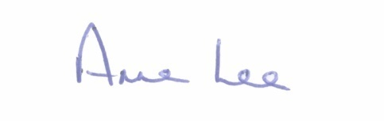

Signed: ____________________
Anne Lee,
Meetings Administrator.

Confirmed and adopted at Granard Municipal District Meeting held on the
28th November 2017.

Signed: _______________
Cathaoirleach.

